**LOS Assignment**

The main aim of this lab session is to provide hands-on experience on

* Getting Help
* Basic Commands
* Navigation
* File System
* simple shell script

1. Getting Help

|  |  |  |  |  |
| --- | --- | --- | --- | --- |
| Task | Command Name | Syntax | Example | Screenshots |
| To get manual page for the known command | man |  | man ls |  |
| To get manual page for the unknown command | Aprops |  | Aprops copy |  |
| To know the source file binary | type |  | Type ls |  |
| To know the path of the command | which |  | Which ls |  |
| To know the command is external or internal | Type |  | Type cd |  |
| To get help for the internal command | Help |  | Help cd |  |
| To list out bash commands | Compgen |  | Compgen -c |  |
| To know the usage of the command | Command --help |  | Ls --help |  |

1. **Basic Commands**

|  |  |  |  |  |
| --- | --- | --- | --- | --- |
| Task | Command Name | Syntax | Example | Screenshots |
| To know today’s date | date |  | date |  |
| To print calendar | cal |  | cal |  |
| To print kernel version | Uname -r |  | Uname -r |  |
| To print default shell | echo $shell |  | echo $shell |  |
| To print currently logged in user | whoami |  | Whoami |  |
| To create shortcut for command | alias |  | alias ll=”ls -la” |  |
| To delete shortcut | unalias |  | Unilais ll |  |
| To change the timestamp of the file | touch |  | Touch -t 202405061022 file.text |  |
| To clear the screen | clear |  | clear |  |
| To create empty files | touch |  | Touch file.txt |  |
| To know disk usage | du |  | du -h |  |
| To know free space in the system | df |  | df -h |  |
| To know about the Linux release | Lsb_release |  | Lsb_release -a |  |

1. **Navigation**

|  |  |  |  |
| --- | --- | --- | --- |
| Task | Command | Syntax | Screenshots |
| To navigate home directory | Cd ~ |  |  |
| To navigate to the parent directory | cd.. |  |  |
| To navigate to the child directory | Cd directoryname |  |  |
| Alternate command to cd | pushd and popd |  |  |
| To go back to the previous directory | Cd - |  |  |
| To go to the root directory | Cd/ |  |  |

1. **File System**

|  |  |  |
| --- | --- | --- |
| **Task** | **Syntax** | **Command** |
| **How to identify the file system** | **df -T** | **df -T** |

1. Create Folder “CYS”
2. Navigate to CYS
3. Create folder LS1 and LS2 under CYS
4. Go back to CYS

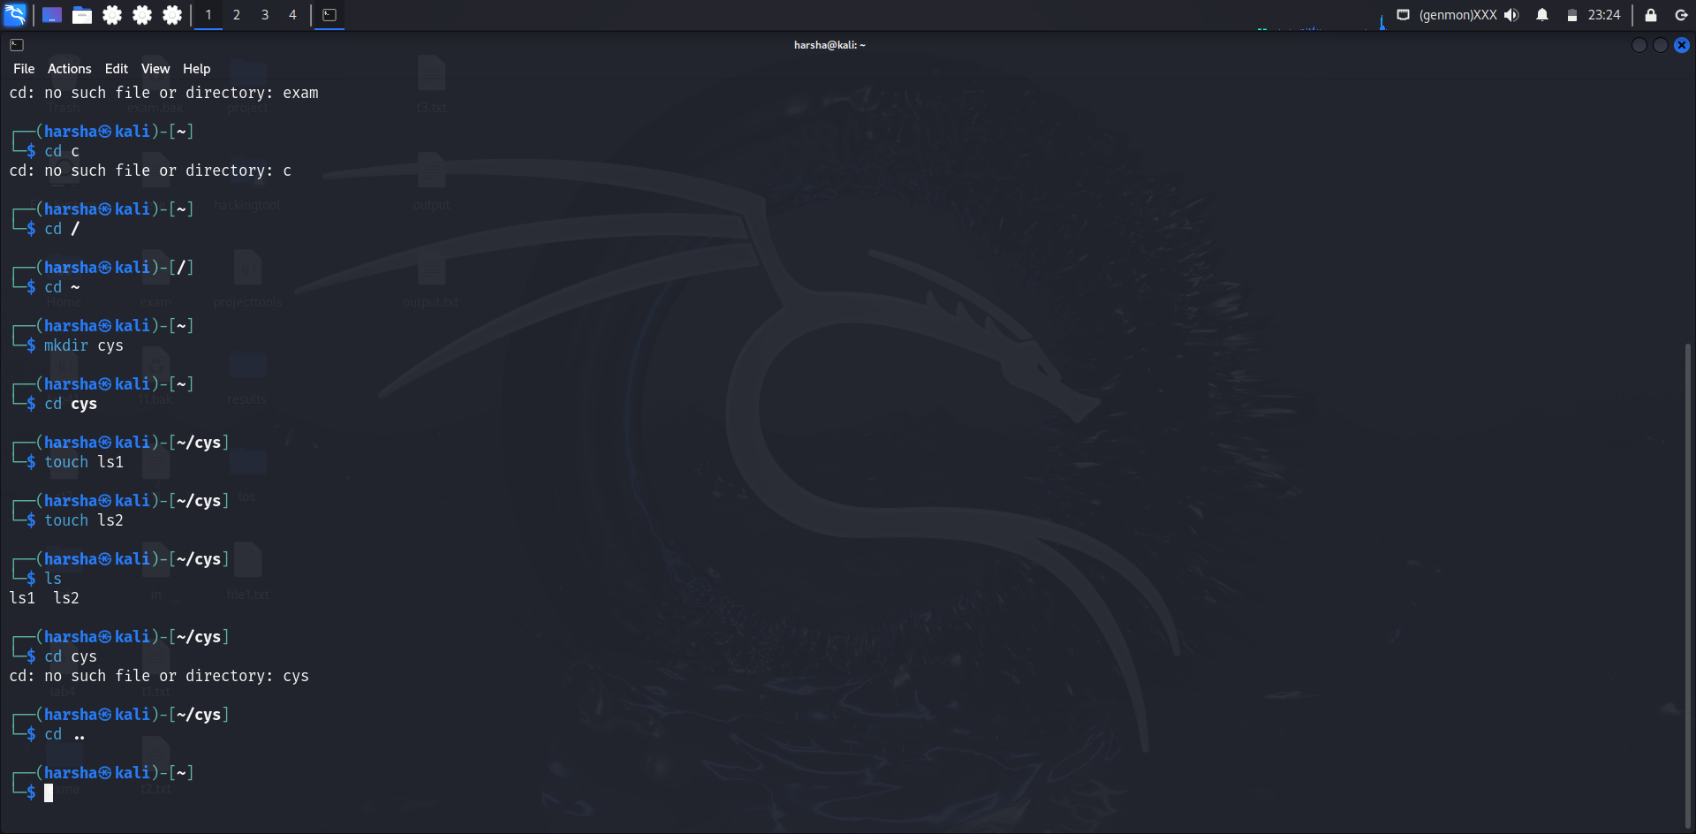

1. Working with Files
2. Add commands which you learnt during lab session in the file commands.txt
3. Change the timestamp of the file to yesterday
4. Copy the contents from the file commands.txt to commands_demo.txt
5. Rename the file commands_demo.txt to duplicate
6. Rename all .html to .hldd
7. Delete the file duplicate
8. Copy the contents commands.txt to unit4 and unit5 (using relative path)
9. Delete the contents from unit5 (using absolute path)
10. Navigate to root
11. List all the files under root
12. Explore all the folders (Do not delete any folder)
13. Navigate to /etc/passwd
14. Open the file passwd
15. Explore the file passwd
16. Navigate to /etc/group and explore

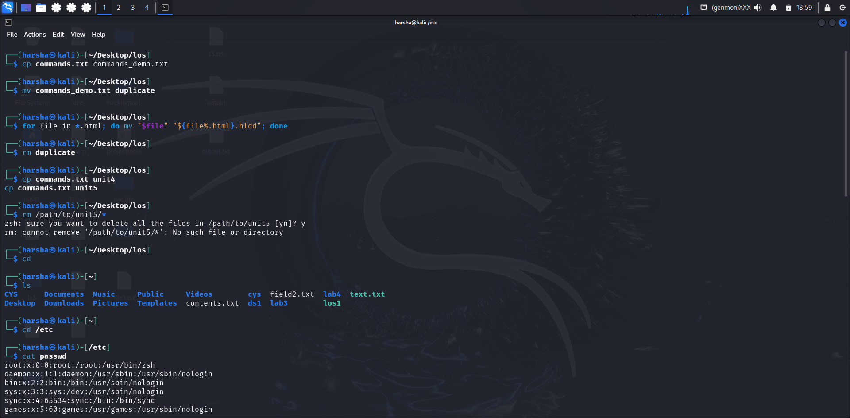

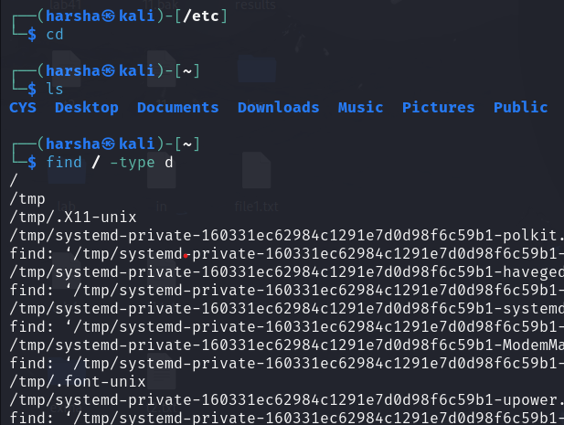

1. **Difference between** 
   * + 1. GUI vs. CLI

|  |  |
| --- | --- |
| **CLI** | **GUI** |
| CLI is difficult to use. | Whereas it is easy to use. |
| It consumes low memory. | While consuming more memory. |
| In CLI we can obtain high precision. | While in it, low precision is obtained. |
| CLI is faster than GUI. | The speed of GUI is slower than CLI. |
| CLI operating system needs only a keyboard. | While GUI operating system needs both a mouse and keyboard. |
| CLI’s appearance can not be modified or changed. | While its appearance can be modified or changed |

* + - 1. man vs info

|  |  |
| --- | --- |
| **Man** | **Info Pages:** |
| Provides concise, straightforward documentation for commands and utilities. | Offers more comprehensive and detailed documentation. |
| Typically a single page with sections like NAME, SYNOPSIS, DESCRIPTION, OPTIONS, and EXAMPLES. | Organized into multiple linked pages, allowing for easier navigation through extensive information. |
| Ideal for quickly looking up specific command details. | Better for in-depth learning and understanding of complex commands or programs. |
| **Example**: man ls displays the manual page for the ls command. | **Example**: info ls provides a detailed, navigable document about the ls command. |

* + - 1. which vs. whereis

|  |  |
| --- | --- |
| **which** | **whereis** |
| Finds the path of the executable file that would be executed in the current environment. | Locates the binary, source, and manual page files for a command. |
| It searches through the directories listed in the PATH environment variable. | It searches through a broader set of directories, including those specified in PATH and MANPATH. |
| which tar will show the path to the tar executable, like /usr/bin/tar. | whereis tar will show paths to the tar binary, source, and manual files |

Terminal vs shell

|  |  |
| --- | --- |
| **Terminal** | **Shell** |
| A terminal is a text input and output environment. | The shell is a command-line [interpreter](https://www.geeksforgeeks.org/compiler-vs-interpreter-2/). |
| A terminal is a wrapper program that runs a shell and allows us to enter commands. | The shell is the program that actually processes commands and outputs results. |
| The terminal is a program that displays a graphical interface and allows you to interact with the shell. | A shell is a user interface for accessing the services of an operating system |

|  |  |
| --- | --- |
|  |  |
|  |  |
|  |  |
|  |  |

1. Write a simple shell script to print your name and your hobbies!

